Association rule:

Support: how often dataset item appears

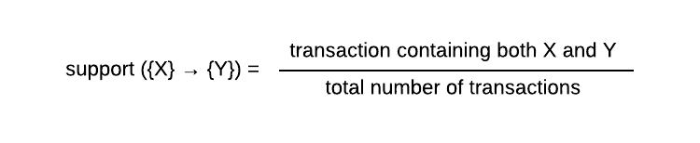

Confidence (conditional probability): likeness of occurrence of consequent given that the antecedent already appears

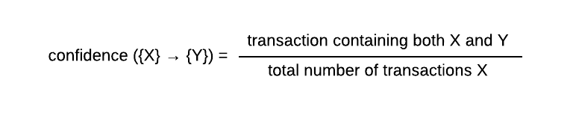

what if Y already has a high probability and confidence ({X} →{Y}) is high too. How can we determine

whether X induces Y.

Lift:

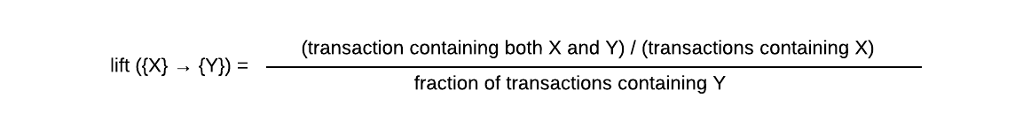



A value lift less than 1 shows that having X does not increase the chance of Y occurrence.

Association rules mainly used in marketing; the most famous example is things recommend in online shopping.

Extend lift: Let A, B → C be an association rule such that conf (B → C) > 0. We define the extended lift of the rule with respect to B as: conf (A, B → C) / conf (B → C). We call B the context, and B → C the base-rule.

Extend lift express the relative variation of confidence due to the extra item in the premise of the base rule B → C:



Let a = v1, B → C be a classification rule, and v2 ∈ dom(a) with conf (a = v2, B → C) minimal and non-zero. Classified lift:

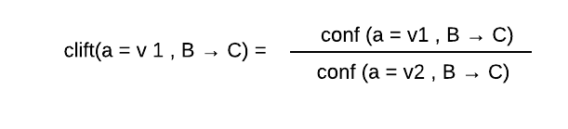

Odds ratio:

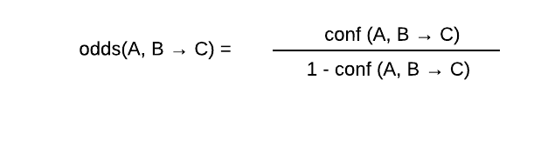

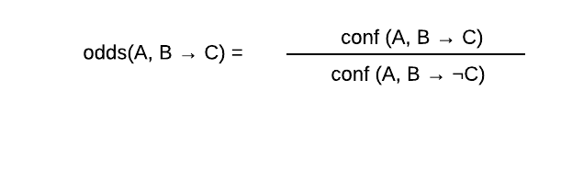

Let A, B → C be a classification rule with conf (¬A, B → C) > 0 and conf (A, B → C) < 1.

The odds lift of the rule is:

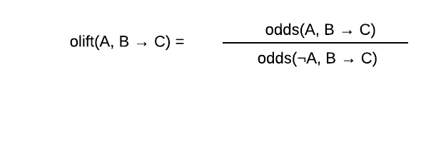

Difference measures: in the U.K., a difference of 5% in confidence between female (A is sex=female) and male (¬A is sex=female) treatment is assumed by courts as significant of discrimination against women.

eliftd(A, B → C) = conf (A, B → C) − conf (B → C)

sliftd(A, B → C) = conf (A, B → C) − conf (¬A, B → C)